LMC 3262 Final Project

Bryce, Soham, James, and Arya

### Table of Contents:

**Initial Ideation**

Locations

Story Ideas

**Idea 3: The Hangover**

Potential Clues

Potential Locations

Story / characters Brainstorming

Deliverables

**Story Outline**

Character 1: Felix - Protagonist

Character 2: Noah - Antagonist (lost boi)

Sequence of events

**Riddles/Mechanics**

# Initial Ideation

## Locations

* Topography of terror area
  + SS headquarters
  + Important Nazi buildings
  + Government buildings
  + Monuments
* Berlin Wall area
  + Berlin wall memorials.
  + River and railings
  + monuments/painting on wall
* Something linear along the river

## Story Ideas

* Saving books from the Nazis along Unter den Linden
  + Hop from site to site trying to save a book
  + **Lose condition**: go to book burning memorial, it died
  + **Win condition**: you find/keep the book
  + Book in question could be a diary of a loved one (but why would someone want to take it?)
* Berlin wall, communist preventing wall from falling
  + Puzzles along wall and river based on paintings
  + **Lose condition** is the present
  + **Win condition** is communism prevails, and west and east germany remain
  + Incorporate historical facts throughout the scenes
* Waking up with no recollection of past
  + You have to figure out what happened, maybe you made some graffiti? And you go along and discover stuff along the way.

# Idea 3: The Hangover

## Potential Clues

* Notebook in pocket (or apple notes screenshot); purpose: cryptic clues to user
* Life360 trajectory; purpose: show you where you’re friend was
* Stickers on wall; purpose: artistic indicator
* Match instagram photo with location in real life
* Receipts in pocket showing dates and locations
* Crumpled up pieces of paper that have notes on them as “clues” if you are stuck
* Pictures with timestamp and location metadata

## Potential Locations

* Alexa mall, Edeka grocery store
* TV tower
* Weird fountain thing
* Other cool fountain thing
* Pink pipes
* Police station
* World clock thing
* Church

## Story / characters Brainstorming

* You:
* Your friend, Bob
* Your other friend, Alice
  + She didn’t go out the night before and is texting you (can be implemented by simple web app on github pages)
  + Serves as the context about yourself, also gives hints, but not omnipresent
* Maybe: you have to save your friend the cops
* Maybe: your friends phone got stolen because you were holding it, and it fell out of your pocket or something and you have to track it down
* Answers that are password locked notes by yourself
* U made the riddle as a drinking game for your friend
* Someone kidnapped your friend and gives you clues to find them
* Starting point - club/bar
* Rich shopaholic friend
* Rich Friend got very drunk and went on shopping spree and leave you behind
* They are trolling you, creates a password-protected notes app to locate him
* Consumerist to contemplative
* Go around the mall, end at church???

## Deliverables

* **Presentation**: everyone
* **Video**: Soham, Bryce
* **Game**
  + React app: Soham, Bryce
    - NavBar
      * Map
      * Notes
      * Photos
  + Puzzles: James
* **Plot**: Bryce, Arya

# Story Outline

## Character 1: Felix - Protagonist

**Motives**

* Wants to have a good night out
* Materialistic, selfish, but wants to be a good friend
* Just trying to get by

**Background**

* German resident in berlin
* 22 yrs old
* Working a low-skill job

## 

## 

## Character 2: Noah - Antagonist (lost boi)

**Motives**

* Bit mentally unstable, very smart
* Overworks in the name of fame and wealth, but has no real direction
* Loves puzzles and cryptography
* Parents are rich and noah likes to use shopping

**Background**

* American in berlin to visit friend
* 23 yrs old

## Sequence of events Brainstorming

Google my maps - <https://www.google.com/maps/d/edit?mid=1j6rk2kCP6c-CwUsEJ0vFpHcZxAvLozw&usp=sharing>

**The Fight**

* What is it about?
* Ends with Noah leaving and roaming out into alexanderplatz in a drunken stupor
* Felix parties for the next few hours and forgets about his friend (*insert obj that he has which indicates this - Ex: “You look into your pocket and find item X)*

**The mission**

* Written as instructions of a sort (“You realize …”)
* Felix realizes that he should probably go find his friend even though they just fought. He begrudgingly starts on the journey
  + His friend also stole his wallet, so he has credit card history
* Tries to call, text, but phone is dead
* Discovery of the life360 breadcrumb trail (how many locations)
* Bunch of internal dialogue like “He must have went shopping no way he made these puzzles for me to find him. I hate him blah blah blah)

**The journey**

* Start - House of Weekend club (right across from alexanderplatz, where the mission desc happens)
* From life360 - Saturn Electronics Store
  + Would all further clues come from solving something in the notes app?
* From notes - Alexa mall
* From notes - World Clock

**Puzzle types:**

1. Basic riddle: 2 or 3 (Saturn store riddle, clock tower riddle, )
2. Match the picture with the location: 2 (cathedral, drill head)
3. Receipts: 1 (Alexa Mall)

# 

# 

# Concrete Sequence w/imgs & puzzles

**General Ideas**

* All notes should hint at the writer being drunk (maybe they go on tangents or make typos)
* Puzzles get more cryptic / drunk as time goes on (one way this happens is that the clues change from clever riddles to hard to follow ideas where you have to cross reference with images)
* None of these notes are finished or polished

Google my maps

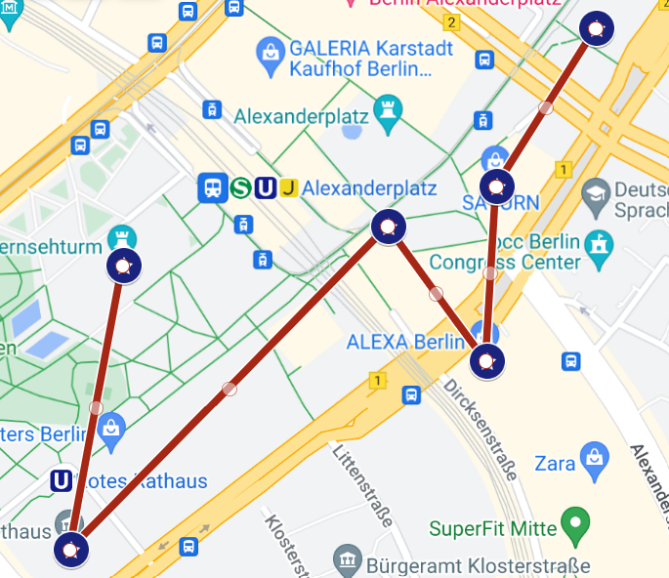

**Location 1**: House of the Weekend Club

**Sources used**: Map, Notes

**Note contents**:

Heeeyyy Felix,

Last night was crazzzzyyyy, right?? You don’t remember much, but you got my stuff and I got yours. Let's play a game, haha. Follow the clues, find me... or maybe I’ll find you. Who knows?!

Start where we ended – House of Weekend. Look for where the music never dies, but tech is shiny n' bright.

I’ve left a series of riddles…

**Whatsapp Conversation Guidelines**:

* I got into a fight with blah blah
* He’s annoying me blah blah
* I think he’s making me go on a puzzle hunt to find him
* I have pieces of his location and some screenshots from his instagram
* Please stay on standby so you can help me out
* Friend tells you to write down all the passwords you use because drunk friend has the tendency to create master answers that require a combination of all previous answers

**WhatApp Script - Roxanne and Noah**

**\* // signifies a message break**

R: Heyy, how was your night out with Felix? Hope you two had fun!!

N: idk what to tell you (straight face emoji) // I just can’t deal with this guy. One moment we’re having a great time and the next he’s calling me an entitled, impatient prick. // Things got heated and I don’t even remember what happened. I called him a nerdy idiot and some other stuff.

R: C’mon you can’t say that. u know he’s sensitive about that // Well anyways, atp just go home and sort it out after you get some sleep.

N: I can’t!! This motherfucker ran off with my wallet. I think he’s making me go on a puzzle hunt (emoji) to find him. I’ll just let him figure it out

R: if he’s super drunk, you can’t just leave him. I know u don’t want to but you have to find him Noah.

N: It’s not my responsibility !! // ok, fine (emoji) // let’s see what I’m working with have his life360 location, but I think his phone died after a while. He also left some stupid notes on my phone. // I gotta lock in for this, im so tired. It is so over for him when I find him.

R: Worry about that later. He likes to post on his instagram story too. Take screenshots of that. // You know much Felix is into puzzles. He’s gonna make this hard. You’ll have to use all the info you can get your hands on.

N: Ok, so I got his location, a bunch of password-protected notes, and his instagram story scrnshots. I think how this works is I have to go to each location and use teh clues from his notes to get the password to the next note. The first note is unlocked.

R: Ok, good luck… if you get stuck on one of his puzzles text me. I can help you out

N: Thx Rox

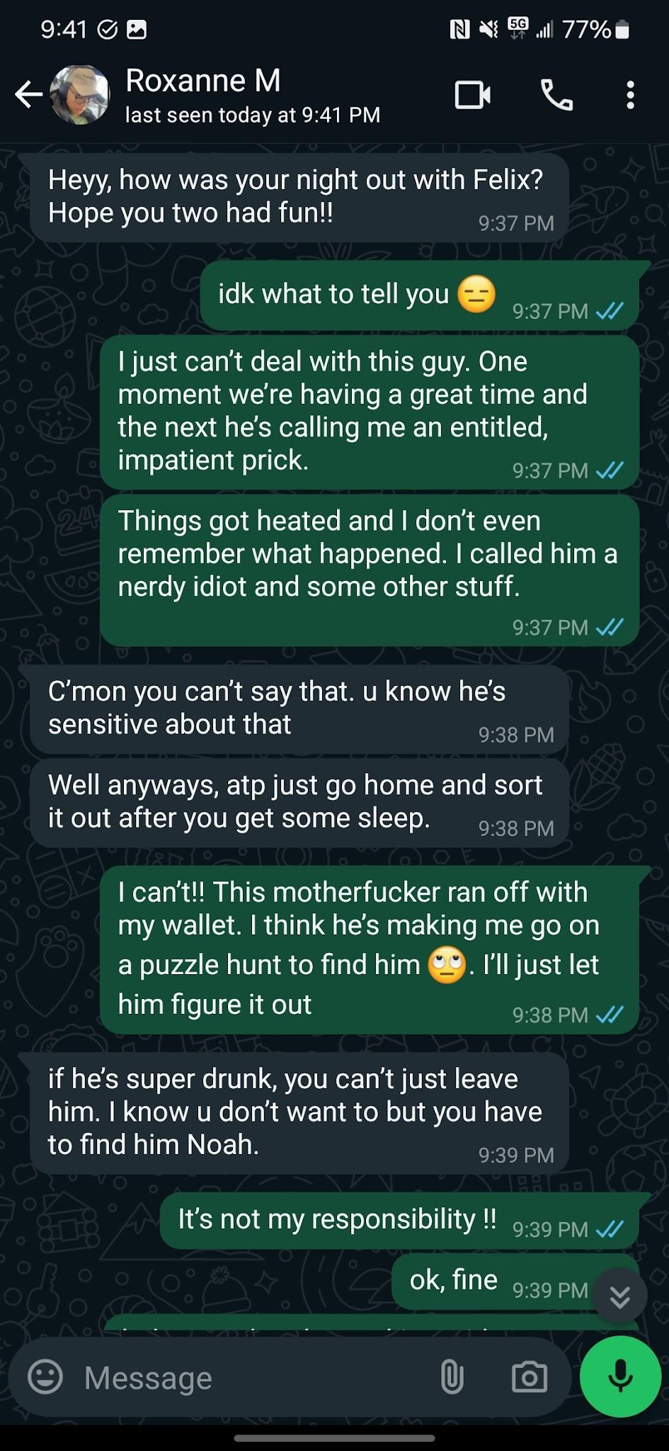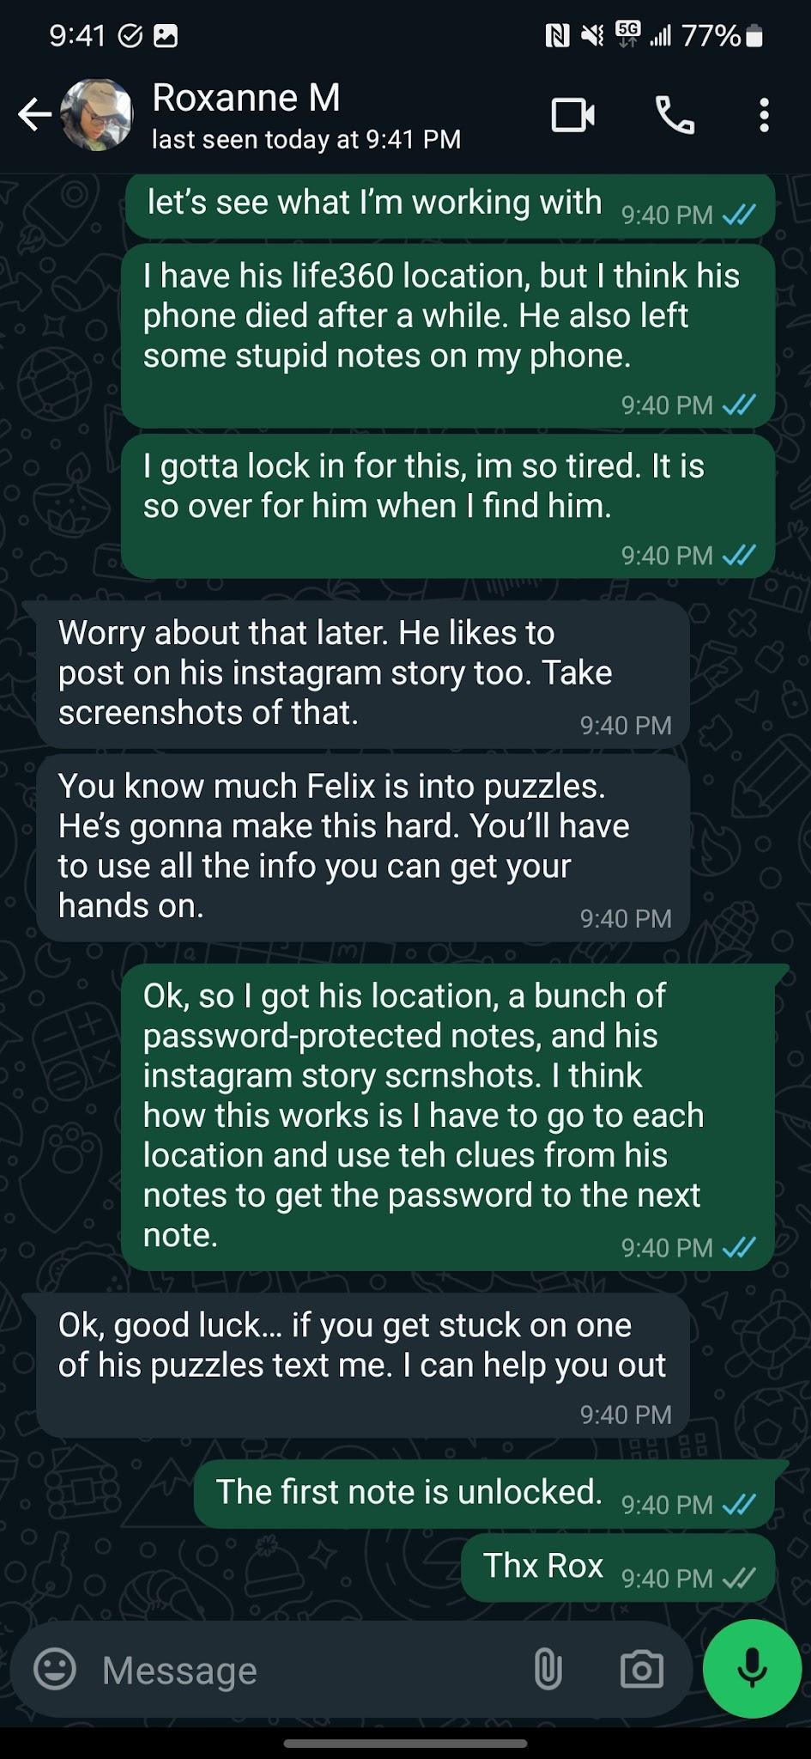

**Sequence**:

* Go to club
* Open note from drunk boi
* Open conversation screenshots
* Walk to Saturn

**Location 2**: Outside Saturn electronics store

**Sources used**: Map, Notes

**Note contents**:

In the place where rings do shine,

Where techies flock and gadgets align.

Count the balls that circle right wide,

Their number is where your answer hides.

(Answer: 5, # of spherical trashcans surrounding the store)

**WhatsApp Script**:

N: I can’t figure this puzzle out. What spheres is he talking about? I sent you the info on Instagram

R: hmm, maybe he wants you to count those metal spheres around the shop. How many are there?

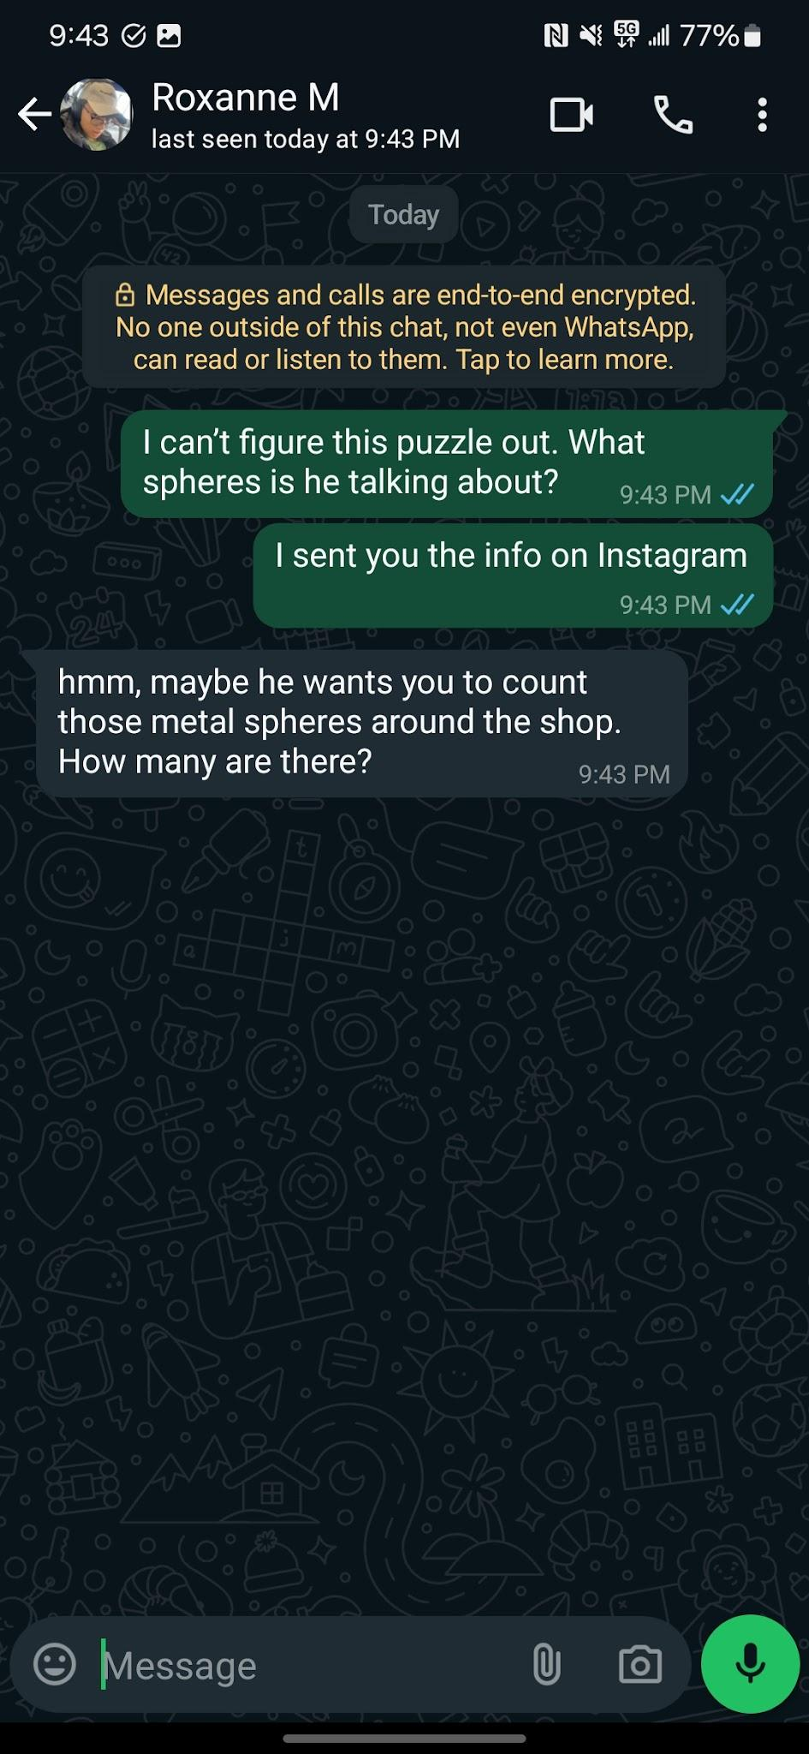

**Sequence of Events**:

* Open note (no password)
* Solve puzzle
* Use password on next note
* Go to Alexa mall

**Location 3**: **Inside / Outside Alexa Mall**

**Sources used**: Map, Notes, Imgs (perhaps??)

**Note contents**:

~~* to be written, there are two ideas. One is that you have to find the price of the scrabble game (puzzle haha) inside a bookstore near the entrance to the mall. The player can find the bookstore through being told in the note or a series of imgs, but that might be overkill. The backup (if mall closed) is that we post a fake receipt on the wall outside (see photo) and you have to do some shit with that.~~

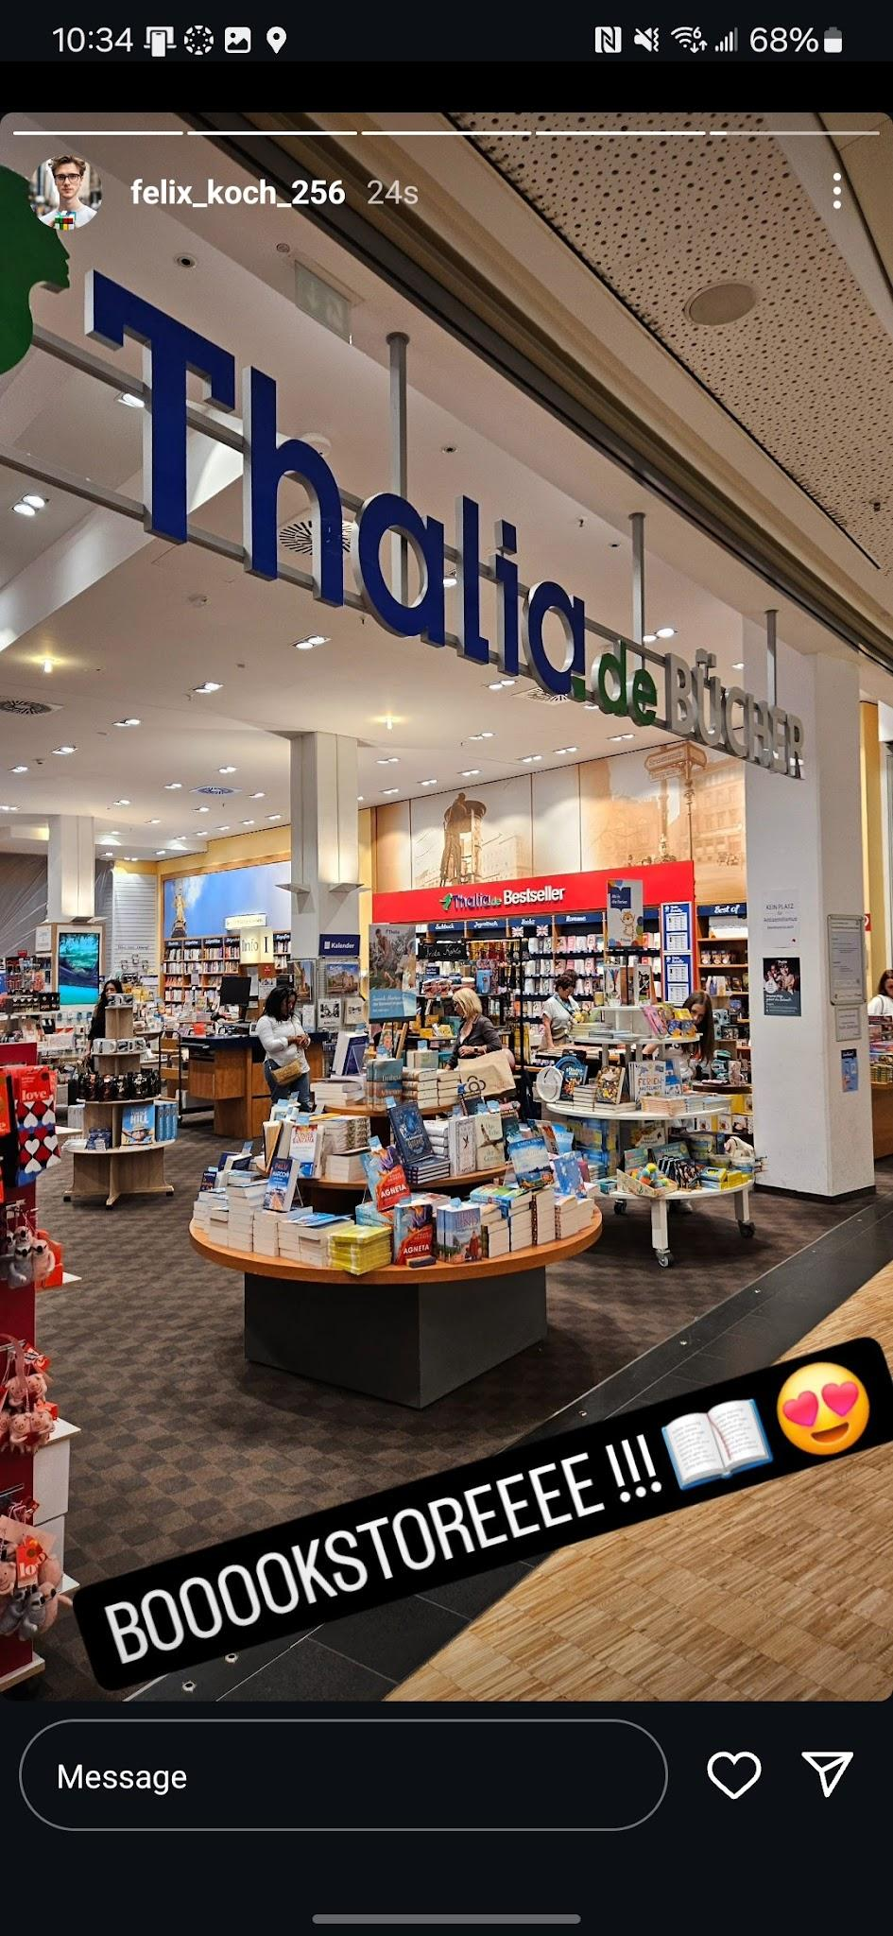

Okay, so you know how much I loooove Scrabble, right? It’s my favorite game ever! I left a clue in a place that sells books and games... yeah, that’s it! Find the Scrabble game in the bookstore at Alexa Mall. Look for it near the entrance. Do you remember how much it costs?

Good luck, buddyyy! Hope you’re having as much fun as I am!

* Open Note and find either directions to bookstore or something leading you to the imgs of the bookstore
* Go to bookstore inside and find puzzle / find the receipt
* Solve puzzle
* Go to world clock

N: Need a little help with this Scrabble one. sent u everything on instagram. // Where do I find this location

R: Hm, maybe search it up on google maps??

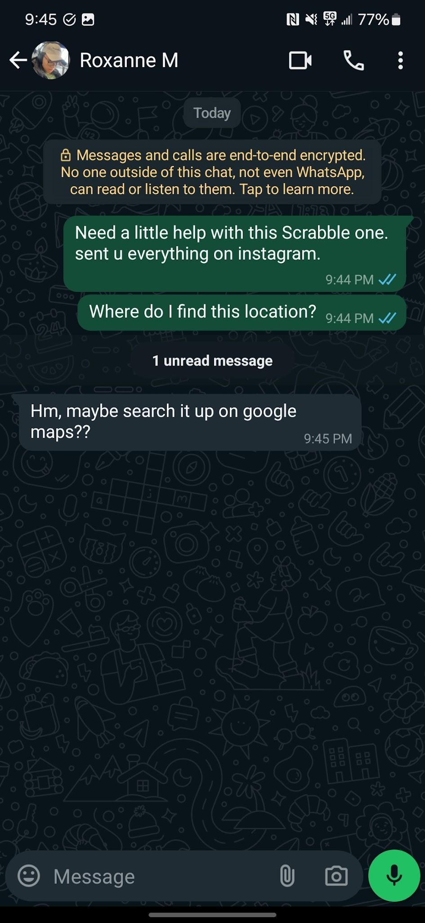

Answer: 1495

**Location 4**: World Clock

**Sources used**: Map, Notes

**Note contents**:

Time for a code, at the clock... thingy,

Where the hours... are wobblyy and spinny.

From reykjavik to wladiwostok -

circle around, as you shall walk,

the hours cut between the time

thus the code that you will find

(Answer: 10, the hours between the two cities on the clock)

**WhatsApp Script**:

N: This one has me stumped. What hours cut what? I drank way too much last night to be doing this. I sent you the info on Instagram again. // Roxanne respond!! I need ur help

R: Ok calm down felix. I can’t respond to you every 2 seconds. // anyways, i think he wants you to count the time difference between those two cities. Try to find them on that clock

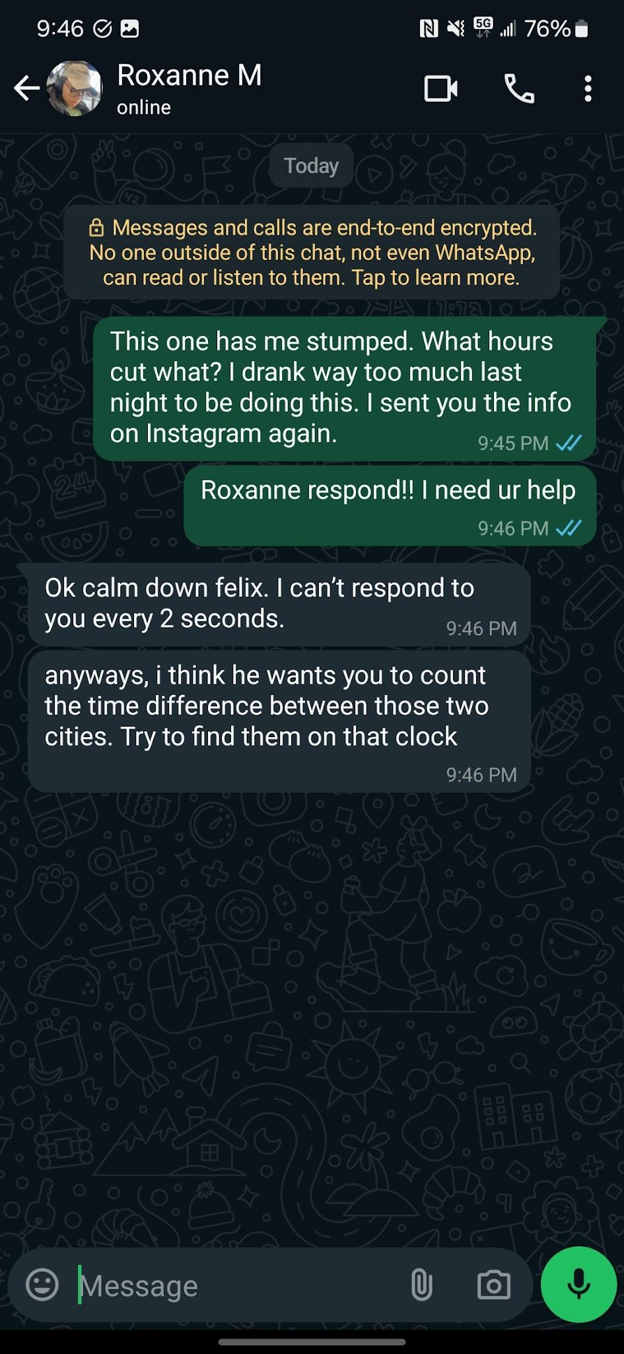

**Sequence of Events**:

* Open note
* Solve riddle
* Use password on next note
* Go to town hall/drill

**Location 5**: town hall / drill

**Sources used**: Map, Notes, Imgs

**Note contents**:

* have to write, will be something involving the text at the base of the drill

* 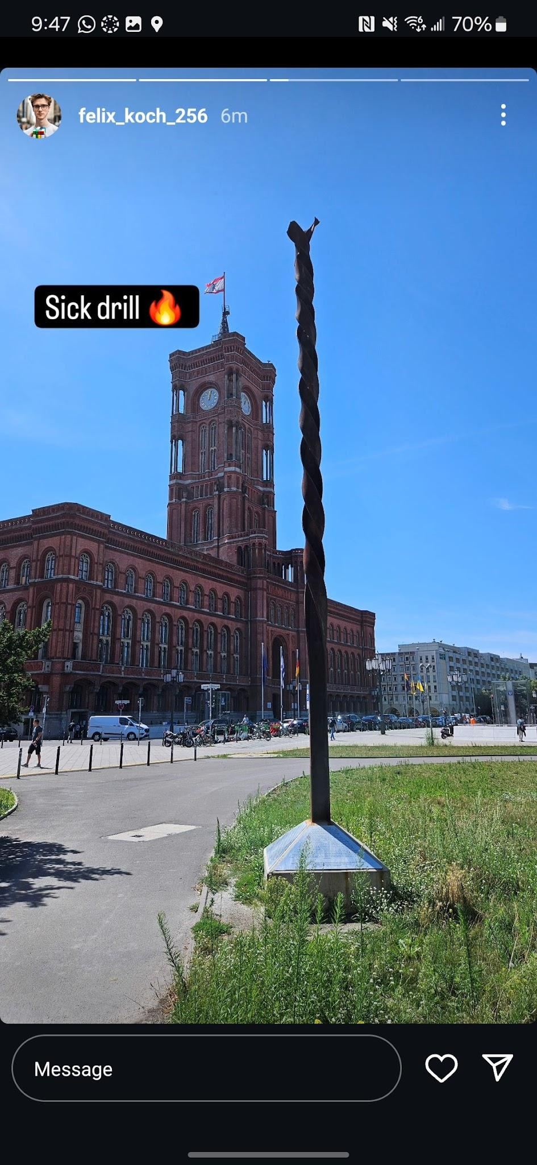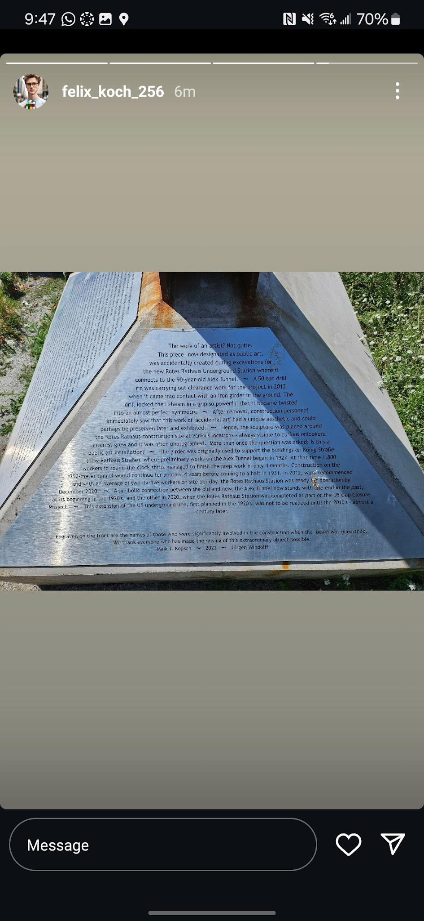

**Sequence of Events**:

Look at the metal twister sign... what’s the date when the workers stopped working?? YOU NEED TO KNOW... it’s all there on the sign! The year... or maybe the month? ITS SO COOL i have to take a picture

Answer: 1931

N: This note is so vague… what’s the twister sign? What workers? // i don’t think felix is making coherent puzzles anymore (emoji). I’m about to give up

R: Wait, check his instagram story. He might have taken a photo of the place where you’re supposed to find the location. I think…

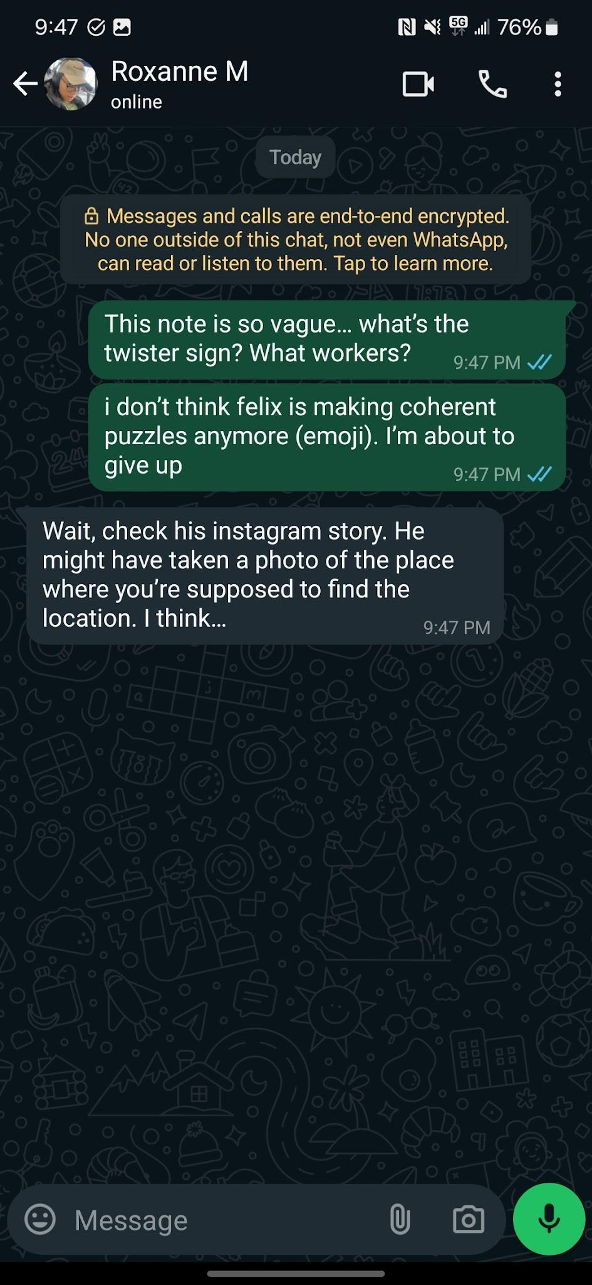

**Sequence of Events**:

* Open note, it doesn’t make sense. Panic! See screenshot of friend telling you that drunk friend is not making coherent clues anymore so you’ll have to be a detective and look at his story imgs
* Use img to find drill
* Solve puzzle using cues from note and drill text
* Use password on next note

**Location 5**: TV Tower / Restaurant

**Sources used**: Map, Notes, Imgs

**Note contents**:

* need to write, something involving the menu at this restaurant at the base of the tv tower

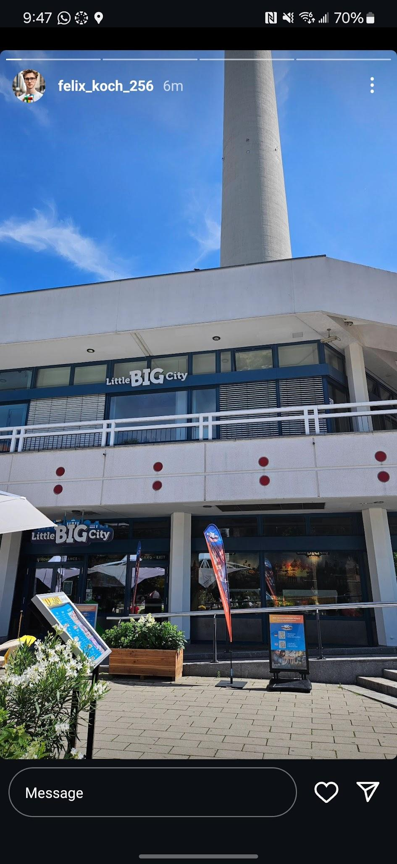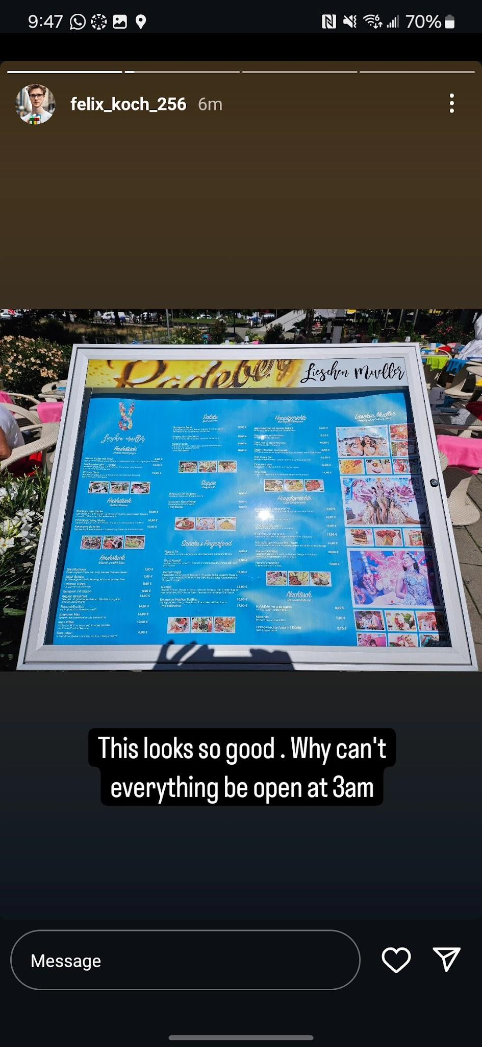

Haha….i got hungry. You better know my favorite order here, we used to go alllllllllll the time. Let just say it was the price of a major betrayal of a time long past, in ancient rome….

Answer: 1390

**Sequence of Events**:

* Open note, it doesn’t make sense, so see a screenshot of friend telling you to look at his story imgs
* Use img to find menu
* Solve puzzle using cues from note and menu
* Unlock next note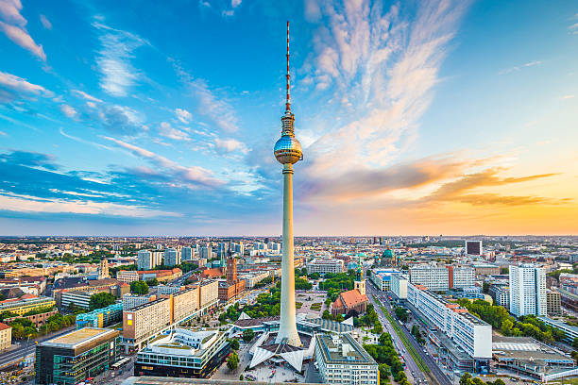

**Location 5**: Church

The whole twist is that the friend donated all of their stuff, and the final note says has a feel of lucidity and sobriety, having a more serious note:

The collection box is full, your journey is complete.

The world is

**Sources used**: Notes, Map

**Note contents**:

* something about the how all the previous passwords have to be used to find this last location. I just noticed I my life360 was on but now I’ve turned it off blah blah blah

Alright, let's combine these to find the final spot. Think about a place where history and time kinda blend together. Somewhere old, like 1931 old, but also kinda central, you know? Look for the place where the bells ring and history sings, near the big TV tower!

Answer: 5, 14.9510193113.90

What do you think this means????

Hes a big stickler for grand combinations…

Like all the past clues ones combined?

I think so…maybe try that out

**Sequence of Events**:

* Open Note
* Solve master puzzle
* Find friend
* **Then what**??

The fight was based around the protagonist's self-centerdenss/greed, so the entire thing is an exercise in patience and greed.

## IG Story Screenshots

Answers: 5, 14.95, 10, 1931, 13.90

Script and casing for video:

Song in the background: tubthumping - chumbawamba

Start with bright flashing and club clips, having fun and then cut to felix getting too drunk and waking up on a bench

Shows noah gtting frustrated and then clip of before saying he definitely wont get drunk

So then noah steals his wallet and walks away

Then we have clips of felix going to the nodes and puzzles looking confusingly

End at them looking at each other and camera cuts to the sky

[WEBSITE LINK](https://b-ricey763.github.io/lmc-3262-final-project/)